

SCHOOL OF ARCHITECTURE, BUILDING & DESIGN MASTER OF ARCHITECTURE URBAN DESIGN STUDIO [ARC70109]

URBAN THEORY: Garden in the City

Tutor : Ar. Sateerah Hassan

Ooi Wenn Yeaw 0332760

Introduction

The Malay conventional enclave of Kampong Bharu is an area of uncertainty. It may also want to transform into a very new modern-day middle in the Kuala Lumpur metropolitan or development that intertwines the antique and new where the ancient man or woman of the region sustains. The social and cultural values of the location could vanish if the new improvement ignores the information of the concepts of life and notion devices of those who inhabit the region. The want and aspiration of the new technology dictate the face of the future improvement. The history values and the social cohesiveness defining the uniqueness of the place have to now not disappear along the emerging redevelopment. Social harmony, social coherence, location identity and pleasantness of life have an impact on the human's proper-being, therefore, have to be equally emphasised in destiny redevelopment tasks.

Based on the historic information from The Malay Agricultural Settlement (MAS), Kampong Bharu turn out to be fashioned on January 12, 1900, through the Federated Malay States at the 223 acres land consisted of seven small villages and administered by manner of the MAS Board of Management. Despite the increasing need for urban improvement to avoid the dilapidated situation of the vintage homes and to revive abandoned regions, the redevelopment plans with the resource of the associated events has been a futile effort.

Urban theory

Outdoor activities and outdoor space quality

It is crucial to Kampong Bharu that the numerous categories of outdoor activities (warung, local stalls, field, etc) are influenced by the quality of outdoor space, and mainly how it is precisely the elective, in large part recreational functions and social sports that are given a chance to broaden in which such high-quality is progressed. Conversely, it's been noted how these very activities have a tendency to disappear where the exceptional has been decreased. In this section, where the difficulty isn't the number of events but the individual and content of outdoor life, it's miles important to note that those sports, which make it in particular appealing and meaningful to be in public spaces, are also the sports that are the most touchy to the pleasant of the bodily environment.

Walking distances and pedestrian routes

This can be decided in Kampong Bharu which can be yet to be designed as greater pedestrian high-quality streets, the ones problems can also additionally prevent the opportunity for website traffic to experience the town with an extra feel of amusement and simplicity with the aid of taking walks. However, offering a comfy pedestrian surroundings within the metropolis centre is a undertaking due to the problems of tourist congestion and restricted regions for pedestrian movement. As such, it has affected the improvement situations as there aren't any included features between the bodily elements through permeability and legibility in the city. The higher the permeability and legibility, the extra continuity and connectivity the town gives in terms of walkability.

Spaces favorable for walking

One of the most essential demands in Kampong Bharu for a well-functioning pedestrian machine is to arrange pedestrian movement to observe the shortest distance between the natural locations within an area. When the issues of the main traffic format are solved, However, it becomes vital to region and design the individual hyperlinks within the community so that the complete system becomes particularly attractive.

Have a better living environment in the Kampong Bharu
In creating a higher residing surroundings in Kampong Bharu, This is intention at imparting the city a friendlier surroundings no longer most effective to the humans or citizens, however additionally the urban ecology.

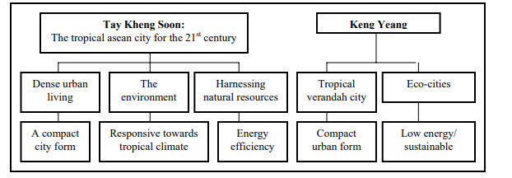

Conclusion

The proposed Nursing Vocational College also adapted the design theory of life between building, the image of the environment and garden in the city to fill up the gap of lack of green space and walking space on the site.

Eventually,An urban layout parameter or guideline is derived. This parameters or suggestions are the keys to the creation of a success city of Kampong Bharu

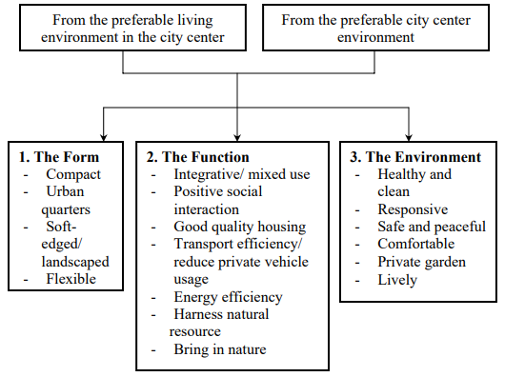

Design, Urban planning and green spaces
The key to a greeneries areas are the environmental blessings they offer. For instance, they counteract the city warm temperature island effect, thereby decreasing the power fees of cooling houses. Urban greenery minimizes air, water, and noise pollutants, and might offset greenhouse gas emissions via carbon dioxide absorption. Urban greenery moreover offers storm water attenuation, thereby performing as a degree for flood mitigation.Further ecological advantages consist of preservation of biodiversity and nature conservation. Consequently, due to the range of environmental offerings they've sufficient money, urban green regions can be regarded as a public precinct.From the health angle, town inexperienced areas are areas that allow fitness-selling sports, which includes physical hobby or relaxation and rest, to take. In this way, they have got an instantaneous courting with the lifestyles of urban dwellers. The variety of purported health blessings of town green spaces is full-size and this is blanketed in the following segment.
Social contact
Urban green area moreover offers possibilities for social interactions to take area. This turn need to help lessen social isolation, generate social capital, and bring about greater personal resilience and health. This seems to be specifically crucial for elderly population corporations. Interestingly, in some research, social elements had a similarly impact on the frequency of use of town parks than the physical functions of the parks.

Open spaces
The wonderful impact of nature and publicity to the outdoors; in the direction of distraction from strain and anxiety degrees of sufferers in a Health care setup. Kampong Bharu humans view scenes which might be soothing to mind and eyes and are universally widespread – like lovely panoramas, sunsets, KL perspectives, green area the nerve cells of the brain come to be energetic and the mind’s natural painkillers begins flowing thereby reducing the stress degrees of the humans and lead them to calm.

Fenestrations
Through my challenge ‘power of the window’ can assist the patients in nursing vocational college recover quicker while their rooms have an instantaneous view of the out of doors natural surroundings rather than a smooth wall, furthermore college college students may have a observe the natural environment in the town. Patients and college college students who should see and experience nature spherical (be it inside the shape of trees or chirping of birds, cool breeze, sunrise, and sundown, and so forth.), required a lot much less stress than those who stayed in a room with brick partitions and no window.
Opportunities urban green space
A capability danger to public inexperienced space is in which the gap is available however access to it's far restrained. This is frequently seen where metropolis land is redeveloped for housing and an green location is furnished but is best reachable to citizens. This is an attractive technique for builders, due to the fact the “fantastic” inexperienced area may also grow the retail value of the property; however, such approaches necessarily develop inequities in getting access to. Similarly, town inexperienced area duties to make more disadvantaged neighborhoods greater healthy and greater appealing can energy up asset values and displace the residents for whom the duties had been designed to be of advantage.

References:
https://www.researchgate.net/publication/321915756_THE_INFLUENCE_OF_WALKABILITY_TOWARDS_URBAN_STREET_DESIGN_INKUALALUMPUR
https://www.researchgate.net/publication/324253901Urban_Revitalisation_for_a_City's_Soul_The_Case_of_Kampong_Bharu
http://eprints.utm.my/id/eprint/843/1/Then_Jit_Hiung%28Malaysia%29.pdf
http://theijes.com/papers/v4-i10/Version-3/H04103055060.pdf
https://www.researchgate.net/publication/271587798_GREEN_CITIES_-_URBAN_PLANNING_MODELSOF_THE_FUTURE
https://link.springer.com/chapter/10.1007/978-3-030-37716-8_1
https://www.re-thinkingthefuture.com/rtf-freshperspectives/a597-therapeutic-architecture-role-of-architecture-in-healing-process/
https://www.researchgate.net/publication/276936256_Bioclimatic_architecture_as_an_opportunity_for_developing_countries
https://www.researchgate.net/publication/316536254_The_Malay_Enclave_of_Kampong_Bharu_as_a_Living_Tradition_Aplace_of_uncertainty
https://www.dovepress.com/value-of-urban-green-spaces-in-promoting-healthy-living-and-wellbeing--peer-reviewed-fulltext-articleRMHP
Jan Gehl LIFE BETWEEN BUILDINGS Using Public Space

